|  |  |  |  |
| --- | --- | --- | --- |
| Angol szóbeli vizsga | Középszint | 1.Vizsgafeladat | Bevezető interjú |

# Vizsgafeladat -vizsgáztatói példány

## Bevezetés (nem értékeljük)

*Mielőtt a tényleges szóbeli vizsga elkezdődik, egy rövid (kb. egyperces) bemelegítő beszélgetés szükséges.*

Vizsgáztató:

* Did you sleep well?
* How are you today?
* What did you do yesterday evening?
* When did you get up?
* Is it the first time you are taking an exam?
* How did you come here?
* Are you planning to have a party after the exam?
* ( If “no”: ) What are you going to do after the exam?
* ​

Now I am going to ask you a few questions. If you can’t understand me, I can repeat the question once. Let’s get started:

## Tényleges vizsga (ettől a résztől értékeljük):

Vizsgáztató:

We are going to talk about eating habits.

A What do you know about healthy eating habits?

**Healthy eating means eating a lot of fruit and vegetables. We should eat 5 portions of fruit or vegetables every day. We should drink at least 2 litres of water. We should have at least 3 meals a day. I have 5 meals a day. I have breakfast, elevenses, lunch, snack and supper every day.**

B How often do you eat in fast food restaurants? or Do you like drive-ins?

**I go to fast food restaurants once a month. My favourite fast food restaurant is McDonalds. I usually eat chips and hamburgers there. I also like coke.**

C What is your favourite food/dish? Can you make it?

**My favourite food is… I can make it, my mother makes it twice a month. The ingredients are …, …, …**

Thank you very much.

That’s the end of your first task.

|  |  |  |  |
| --- | --- | --- | --- |
| Angol szóbeli vizsga | Középszint | 2.Vizsgafeladat | Szituációs feladat |

# Vizsgafeladat - vizsgáztatói példány

*A vizsgáztató átadja a vizsgázónak a vizsgázó feladatlapját. A vizsgázó kb. fél percig készülhet.*

**A VIZSGÁZÓ PÉLDÁNYA**

You worked as a receptionist in a hotel in the summer. You had to work in night-shift, so you need to relax a bit. Talk to your mother about your experience.

Talk about the following points:

* Tell your mother about the work (place, type of work, salary).
* The number of new friends you made.
* Ask your mother if you should spend your money on a new phone or a laptop.
* You can help her later because you are very tired.

Prompts for the interlocutor:

You are the mother. Listen to your child’s work experience. Ask questions about his/her experience.

* I’m so happy that you’re at home. I’m very excited to hear something about your summer job.
* **I have worked a lot in a hotel in the last few weeks.**
* What is the name of the hotel where you worked? What did you do exactly?
* **The hotel is called Sunshine Hotel. I worked as a receptionist there.**
* How much money did you earn?
* **I earned quite a lot of money.**
* Did you make new friends? (How many?)
* **I made 4 new friends there. I would like to buy a new phone or a new laptop but I can’t decide. Which one should I choose?**
* I think, a new laptop would be more useful.
* **That’s OK.**
* I need your help in the kitchen.
* **I’m sorry, I can’t help you now, I’m very tired.**
* Ok, let’s talk a bit later.

|  |  |  |  |
| --- | --- | --- | --- |
| Angol szóbeli vizsga | Középszint | 3.Vizsgafeladat | Önálló témakifejtés |

# Vizsgafeladat - vizsgáztatói példány

*A vizsgáztató átadja a vizsgázónak a vizsgázó feladatlapját. A vizsgázó kb. fél percig készülhet.*

**A VIZSGÁZÓ PÉLDÁNYA**

These two pictures show different Christmas scenes.

Compare and contrast the two pictures. Include the following points:

* Which Christmas Eve would you prefer?
* Describe the importance of holidays in family life.
* How do you celebrate Christmas?

**I can see a big, happy family celebrating Christmas in the first picture. In the second picture there is a lonely woman celebrating Christmas.**

**I prefer the first picture because I think family is an important thing in my life.**

**Holidays are important in family life. It helps the family come together; the relationships can become stronger.**

**Christmas has 2 days: the 25th of December is called Christmas Day and the 26th of December is called Boxing Day. The 24th of December is called Christmas Eve. On Christmas Eve we decorate the Christmas tree, we give presents to each other. In the evening we have a big dinner together. We usually have turkey, fish, stuffed cabbage and beigli. On Christmas Day and Boxing Day we have guests and we meet our relatives.**

Prompts for the interlocutor:

* How do you prepare for Christmas?
* What about buying presents/cooking the X-mas dinner/decorating the tree etc.?
* Do you think that spending Christmas alone is common?
* Would you describe the best Christmas you have ever had? Why was it he best?

**THANK YOU, THIS IS THE END OF YOUR EXAMINATION.**

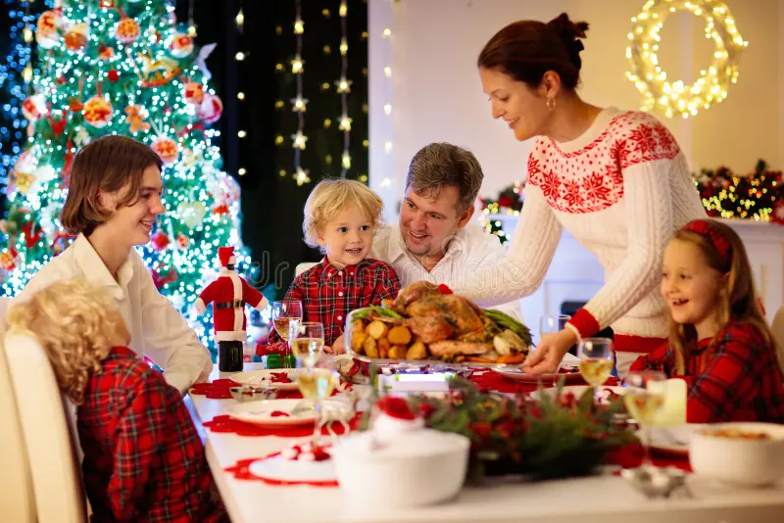



|  |  |  |  |
| --- | --- | --- | --- |
| Angol szóbeli vizsga | Közép szint | 2.Vizsga feladat | Szituációs feladat |

1. **Vizsgafeladat - vizsgázói példány**

**A VIZSGÁZÓ PÉLDÁNYA**

You worked as a receptionist in a hotel in the summer. You had to work in night-shift, so you need to relax a bit. Talk to your mother about your experience.

Talk about the following points:

* Tell your mother about the work (place, type of work, salary).
* The number of new friends you made.
* Ask your mother if you should spend your money on a new phone or a laptop.
* You can help her later because you are very tired.

|  |  |  |  |
| --- | --- | --- | --- |
| Angol szóbeli vizsga | Középszint | 3.Vizsga feladat | Önálló témakifejtés |

1. **Vizsgafeladat - vizsgázói példány**

**A VIZSGÁZÓ PÉLDÁNYA**

These two pictures show different Christmas scenes.

Compare and contrast the two pictures. Include the following points:

* Which Christmas Eve would you prefer?
* Describe the importance of holidays in family life.
* How do you celebrate Christmas?



